Managing Files and Directories

8.1 Globbing
Glob characters are often referred to as wild cards. These are symbol characters that have special meaning to the shell.
Globs are powerful because they allow you to specify patterns that match filenames in a directory. So instead of manipulating a single file at a time, you can easily execute commands that affect many files. For instance, by using glob characters, it is possible to manipulate all files with a specific extension or with a particular filename length.
Glob characters are interpreted by the shell itself before it attempts to run any command.

8.1.1 Asterisk * Character
The asterisk * character is used to represent zero or more of any character in a filename. For example, to display all of the files in the /etc directory that begin with the letter t:
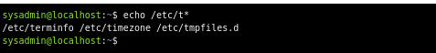

8.1.2 Question Mark ? Character
The question mark ? character represents any single character. Each question mark character matches exactly one character, no more and no less.
Suppose you want to display all of the files in the /etc directory that begin with the letter t and have exactly 7 characters after the t character:
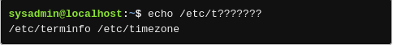

8.1.3 Bracket [ ] Characters
The bracket [] characters are used to match a single character by representing a range of characters that are possible match characters. For example, the /etc/[gu]* pattern matches any file that begins with either a g or u character and contains zero or more additional characters:
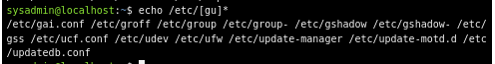

8.1.4 Exclamation Point ! Character
The exclamation point ! character is used in conjunction with the square brackets to negate a range. For example, the pattern /etc/[!DP]* matches any file that does not begin with a D or P.
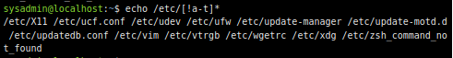

8.2 Copying Files
The cp command is used to copy files. It requires a source and a destination. The structure of the command is as follows:
cp [source] [destination]
The source is the file to be copied. The destination is where the copy is to be located. When successful, the cp command does not have any output (no news is good news). The following command copies the /etc/hosts file to your home directory:
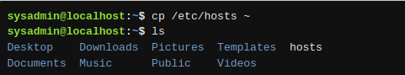

8.2.1 Verbose Mode
The -v option causes the cp command to produce output if successful. The -v option stands for verbose:
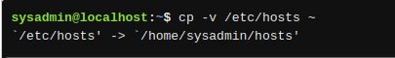

When the destination is a directory, the resulting new file keeps the same name as the original file. To give the new file a different name, provide the new name as part of the destination:
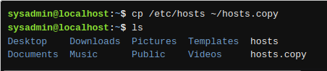

8.2.2 Avoid Overwriting Data
The cp command can be destructive to existing data if the destination file already exists. In the case where the destination file exists, the cp command overwrites the existing file's contents with the contents of the source file.
Two options can be used to safeguard against accidental overwrites. With the -i interactive option, the cp command prompts the user before overwriting a file. The following example demonstrates this option, first restoring the content of the original file:
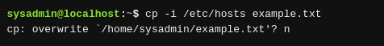

To answer n to each prompt automatically, use the -n option. It stands for no clobber, or no overwrite.
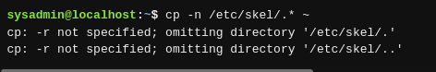

8.2.3 Copying Directories
By default, the cp command will not copy directories; any attempt to do so results in an error message:
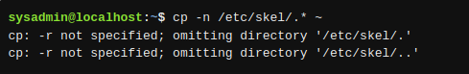

However, the recursive -r option has the cp command copy both files and directories.

8.3 Moving Files
To move a file, use the mv command. The syntax for the mv command is much like the cp command:
mv [source] [destination]

8.3.1 Renaming Files
The mv command is not just used to move a file, but also to rename a file. If the destination for the mv command is a directory, the file is moved to the directory specified. The name of the file only changes if a destination file name is also specified.
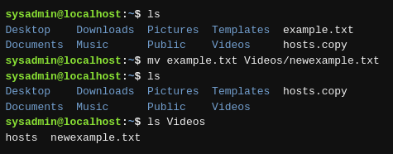

If a destination directory is not specified, the file is renamed using the destination file name and remains in the source directory. For example, the following commands renames the newexample.txt file to myfile.txt:
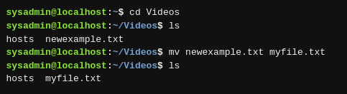

Like the cp command, the mv command provides the following options:

-i | Interactive: Ask if a file is to be overwritten.
-n | No Clobber: Do not overwrite a destination file's contents.
-v | Verbose: Show the resulting move.

8.4 Removing Files
To delete a file, use the rm command:
As a precaution, users should use the -i option when deleting multiple files:
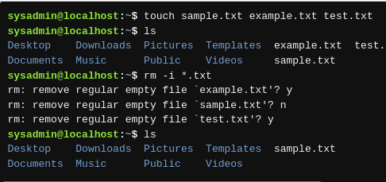

8.4.1 Removing Directories
To delete a directory with the rm command, use the -r recursive option.
You can also delete a directory with the rmdir command, but only if the directory is empty.

8.5 Creating Directories
To create a directory, use the mkdir command:
